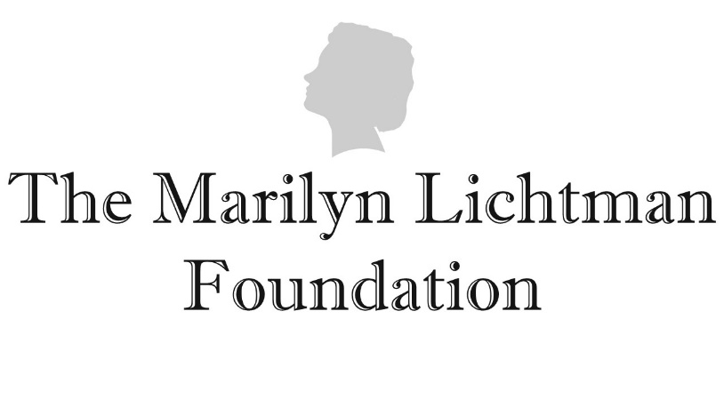

Grant Application
Thank you for your interest in the Marilyn Lichtman Foundation grant program. Please complete the below application and submit it to RBrull@marilynlichtmanfoundation.org with the subject line “Grant Application from [Name of Applicant Organization]”. Incomplete applications will not be reviewed or considered. Please contact us at RBrull@marilynlichtmanfoundation.org with any questions.

- Date: _______________
- Name of Organization to which grant would be paid: _____________________________
Please list exact legal name.
- Brief summary of the Organization’s history, charitable mission and goals:
________________________________________________________________________________________________________________________________________________
- Reason you are requesting grant funds:
________________________________________________________________________________________________________________________________________________________________________________________________________________________
One-two sentences only, please.
- Address of Organization: ___________________________________________________
- Employer Identification Number (EIN)/Federal Tax ID#: ___________________
- Executive Director (or CEO or President, if the Organization has no Executive Director):
  - Name: ______________________________
  - Telephone number: ____________________
  - Fax number: __________________________
  - Email address: ________________________
- Is your Organization a 501(c)(3) non-profit? Yes ☐ or No ☐
  - If no, please explain:
____________________________________________________________________________________________________________________________________
- Amount of request: $_______________
- What would this grant be used for?
  - To provide general support to the Organization ☐
  - To help the Organization with a specific program or project ☐
If you checked by 10(b) above, please provide additional information about the program or project you wish to support with the grant funds, including (i) the name of the project, (ii) a summary of the program or project’s objectives and goals including who will benefit from it, (iii) the projected total program or project cost, (iv) the projected duration of the program or project, (v) how the grant funds would be used in connection with the program or project, and (vi) the expected outcomes of the program or project. Attach additional sheets if necessary.
______________________________________________________________________________________________________________________________________________________________________________________________________
- In what geographic location(s) will the funds be used? ___________________________
* * *
In addition to completing the above sections, please also submit (1) a copy of your Organization’s IRS tax exemption determination letter, (2) your program/project budget, (3) audited financial statements from your Organization’s last fiscal year, (4) a copy of your most recent IRS Form 990, and (5) a copy of any public promotional materials used by your Organization or a link to such materials.

