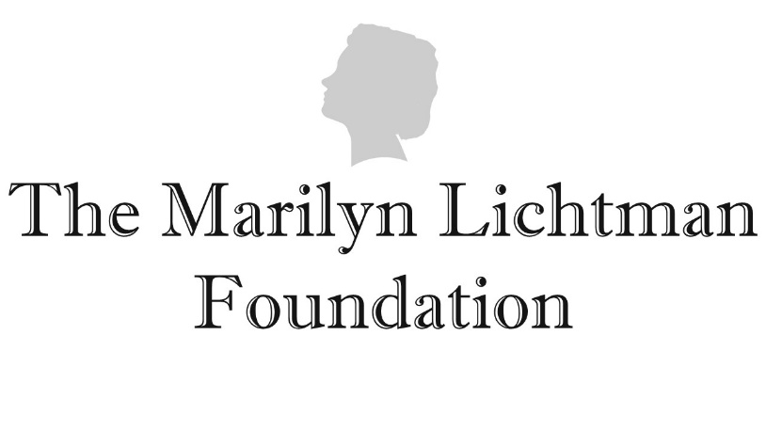

**Grant Application**

Thank you for your interest in the Marilyn Lichtman Foundation grant program. Please complete the below application and submit it to RBrull@marilynlichtmanfoundation.org with the subject line “Grant Application from [Name of Applicant Organization]”. Incomplete applications will not be reviewed or considered. Please contact us at RBrull@marilynlichtmanfoundation.org with any questions.

1. Date: _______________
2. Amount of grant request: $____________________________
3. Name of Organization to which grant would be paid: _____________________________

Please list exact legal name.

1. Address of Organization: _______________________________________________________________
2. Employer Identification Number (EIN)/Federal Tax ID#: _____________________________________
3. Executive Director (or CEO or President, if the Organization has no Executive Director):
   1. Name: ________________________________
   2. Telephone Number: ________________________
   3. Email address: _____________________________
4. Grant Writer/Grant Contact:
   1. Name: _____________________________
   2. Telephone Number: ___________________________
   3. Email address: _______________________________
5. Is your Organization a 501(c)(3) Yes 🞏 No 🞏
   1. If no, please explain:

____________________________________________________________________________

1. Has your organization previously applied for a grant from the Marilyn Lichtman Foundation?

Yes  or No

* 1. If yes, please provide date(s) of prior Grant Application(s):___________________________.
  2. If yes, and a grant was received, please provide date(s) of Grant Notification and Acceptance Letter(s) from the Marilyn Lichtman Foundation and amount of the grant(s) received:
     1. Date: __________________________Amount $ _______________________________
     2. Date: __________________________Amount $ _______________________________
     3. Date: __________________________Amount $________________________________
     4. Date: __________________________Amount $________________________________
  3. If yes, and a grant was received, please provide date(s) your organization submitted the Grantee Report(s) to the Marilyn Lichtman Foundation: ____________________________________.

1. Brief summary of the Organization’s history, charitable mission and goals:

________________________________________________________________________________________________________________________________________________________________________

1. Brief explanation of how the Organization fulfills its charitable mission and meets its goals, and how it measures success in achieving the goals: ________________________________________________________________________________________________________________________________________________________________________
2. Reason you are requesting grant funds: [One-two sentences only, please.]

________________________________________________________________________________________________________________________________________________________________________

1. What would this grant be used for?
   1. To provide general support to the Organization
   2. To help the Organization with a specific program or project

If you checked by 13(b) above, please provide additional information about the program or project you wish to support with the grant funds, including:

* + - 1. the name of the project,
      2. a summary of the program or project’s objectives and goals including who will benefit from it,
      3. the projected total program or project budget/cost,
      4. the projected duration of the program or project,
      5. how the grant funds would be used in connection with the program or project, and
      6. the expected outcomes of the program or project. Attach additional sheets if necessary.

________________________________________________________________________________________________________________________________________________________________________

1. In what geographic location(s) will the grant funds be used? __________________________________
2. How often does the Organization’s board of directors meet? ___________________________________
3. Does the Organization’s board of directors have a finance committee: Yes 🞏 No 🞏
4. Does the Organization have an annual budget that is approved by the board of directors? Yes 🞏 No 🞏
5. Does the Organization have quarterly cash flow and/or other financial statements? Yes 🞏 No 🞏
   1. If yes, are the quarterly cash flow and/or financial statements reviewed by the board of directors and compared with the annual budget? Yes 🞏 No 🞏
6. In addition to completing the above sections, please also submit:
   1. a copy of your Organization’s IRS tax exemption determination letter,
   2. your most recent audited financial statements,
   3. a copy of your most recent IRS Form 990, and
   4. a copy of any public promotional materials used by your Organization or a link to such materials.